**E-Commerce website**

Abstract:

Online shopping is something that most of us take for granted these days. We enjoy the convenience and other benefits of shopping online.

However it wasn’t that long ago that we couldn’t shop online from home at all. Online shopping didn’t even develop until the mid-1990’s.

When we remember that, we realize that we’re still in the early stages of online shopping.

We’re still learning what works, what doesn’t and how we can improve this great shopping option so that it’s even better in the future than it is today.

Customer Flow diagram:

View products /contact us

Result

Log out

Login

Customer

REGISTRATION

Vendor Flow diagram:

Add/delete product

View all products

Log out

Login

Vendor

REGISTRATION

Admin Flow diagram:

View customer/vendors

Delete customer/vendor

Log out

Login verification

Admin login

**PROJECT TECHNOLOGY:**

* HTML
* CSS
* Spring And Hibernate
* Java Script
* MySql
* JSP
* Servlets

Index page:

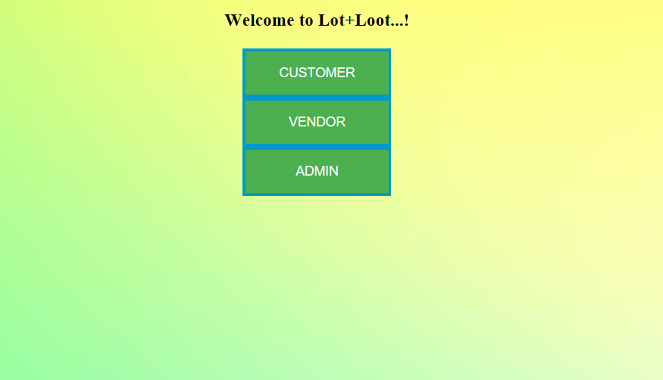

Admin page:

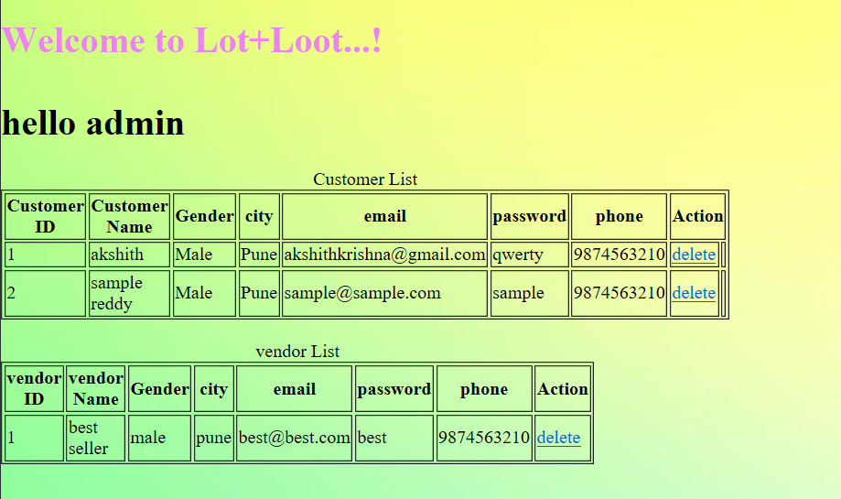

Vendor page:

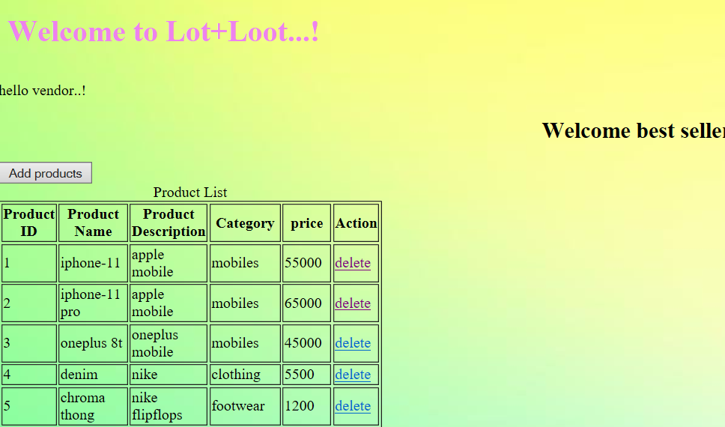

Customer home page:

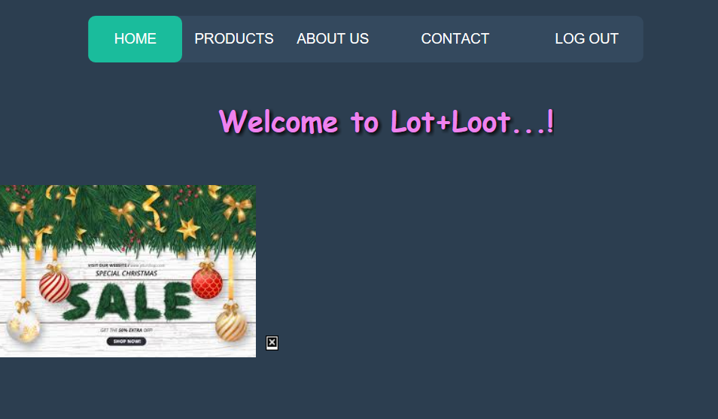

Product page:

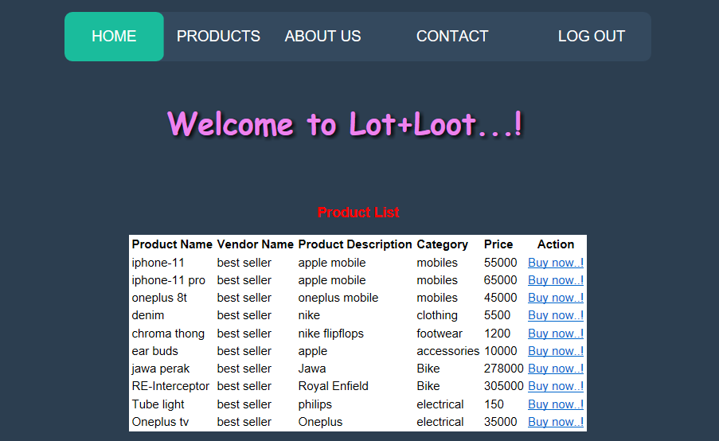

Customer contacting site:

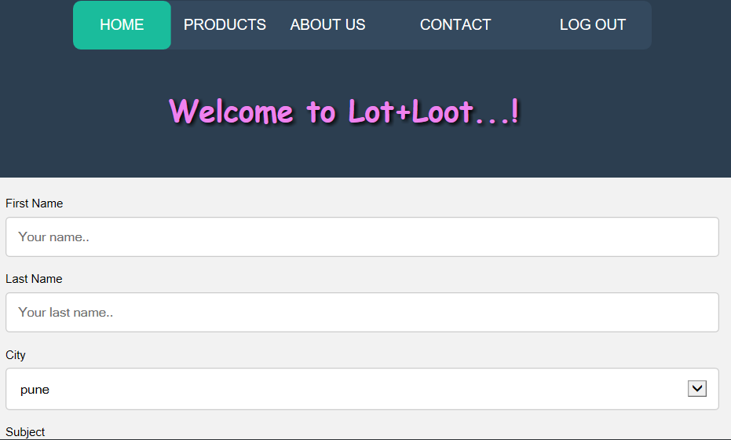

Payment page:

